Rohde & Schwarz  
PA Compression Test  
User manual

February 25, 2016

Table of contents:

1. Pulsed RF Measurements
   1. ZVAX setup
   2. Calibrating pulsed RF setup in CW mode
   3. Pulsed RF setup
2. Performing compression measurements
3. Physical setup ?
4. Reference channel setup
5. PA Compression Test Installation
6. User interface
   1. Settings tab
   2. Plots tab
   3. Progress screen
   4. Mini user interface mode
7. Performing measurement
8. Plotting
9. Mini user interface mode
10. Exporting data

# Pulsed RF Measurements

The Rohde & Schwarz ZVAX line of extension units can be used with a ZVA vector network analyzer to perform pulsed RF measurements. This section provides a simple introduction to setting up, calibrating and performing pulsed RF measurements with these extension units.

## ZVAX Extension Unit Setup

Unfortunately, the physical RF setup of the ZVA and the ZVAX extension unit depends largely on your specific measurement requirements. Therefore, in this section we will concentrate on the non-RF part of the setup.

Make sure the ZVAX is turned on. On the rear of the ZVAX you will see two relevant connections:

1. USB FROM NWA - USB type B jack: This should be connected to any available USB type A jack on the ZVA with an appropriate cable. This connection allows the configuration of the ZVAX to be controlled through the appropriate ZVA menu (see section #).
2. 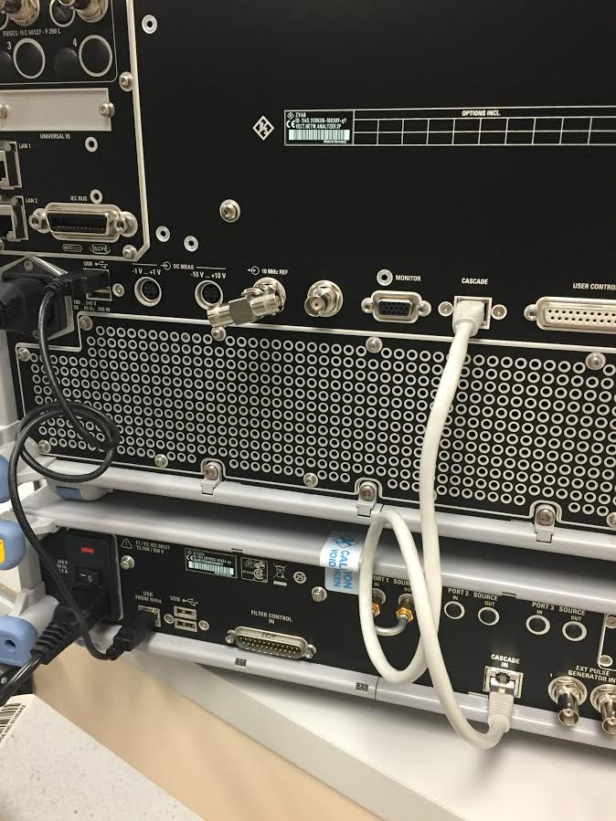 Cascade In: Connect this to the Cascade jack on the ZVA using the cable included with the ZVAX Extension Unit. This connection provides the timing signal from the ZVA to ZVAX unit. Specifically, this signal will control the RF modulator switch.

Cascade In

Cascade

USB From NWA

Figure 2: ZVAX to ZVA Connections

## Calibrating Pulsed RF Setup

To perform accurate compression measurements, we need to perform two calibrations: a standard VNA calibration (such as Thru-Open-Short-Match, or TOSM) and a power calibration.

For this we will need:

1. A calibration kit or calibration unit
2. A power sensor, such as the Rohde & Schwarz NRP-Z91

It is best to calibrate the VNA with settings and a physical setup as close to the measurement conditions as possible. Note that a pulsed RF setup performs the measurement during the period where the pulse modulator switch is on. The VNA is able to perform a standard calibration in these conditions. However, the power sensor measures average power. If we were to try to do a power calibration on a pulsed RF setup, the average power would be below the peak (CW) power by a factor related to the duty cycle. While it is possible to perform a power cal in pulsed RF and compensate for this, it is generally easier to turn off pulsing instead.

**To use the ZVAX Extension Unit with CW RF through the pulse path:**

1. Go to Mode -> Pulse Settings -> Always high
2. Go to Sweep -> Trigger -> Free Run

Make sure the measurement channel is set up for the frequency range that you’d like to measure before proceeding on to calibration. If in doubt, you can always pick a wider range; the instrument can interpolate the calibration for you as long as it is equal to or greater than the measurement range.

Also choose an appropriate number of points, power level and IF BW.

**To perform S-Parameter calibration:**

Cal -> Start calibration (manual)

For many power amplifier measurement setups, a full TOSM or UOSM calibration is not possible because of the coupling mechanisms and attenuation used at the output of the amplifier. Fortunately, for most power amplifier measurements a One Path Two Port calibration is sufficient, as we are mainly interested in input match and gain.

To perform a power calibration:

1. Connect USB or Ethernet power sensor to the ZVA
2. Connect the power sensor input to the power calibration plane in your physical setup
3. Cal (hardkey) -> Start Power Cal -> Source Power Cal…
4. Make sure Source: Port 1
5. If you are using a driver amplifier, click Modify Source Power Cal Settings and enter the approximate gain of the amplifier in the Cal Offset field.
6. In the Modify Source Power Cal Settings dialog, you may also want to adjust the Maximum Number of Readings and Tolerance to ensure that the result of the power cal is acceptable to you. This determines how many iterations are used to calibrate the power source, and how close to perfect the result must be to pass.
7. Make sure that the Reference Receiver Cal is checked. This is very important, as the reference receiver will be used to measure Pin values during measurement, and the accuracy of these values (and therefore the compression measurement) depends on an accurately power calibrated reference receiver.
8. Make sure Use Reference Receiver After is selected
9. Auto Zero power sensor while disconnected from RF
10. Click Take Sweep
11. Confirm that the power cal converged on the correct power level across frequency, and that the error is within the tolerance.
12. Disconnect the power sensor from your setup and connect the device under test.

## Pulsed RF Setup

Now that we are done calibrating, we can put the measurement back into pulsed RF.

1. Mode -> Pulse settings -> single pulse
2. Sweep -> Trigger -> Pulse Gen…

# Performing compression measurements

Input Power (Pin)

Output Power (Pout)

Gain  
G(f, Pin)

S1

a1

b1

S2

a2

b2

Power Cal. Plane

Calibration Planes

Port1

Port1

Figure 1: General compression test setup

To perform a useful amplifier compression measurement, we need to be able to accurately measure the input power Pin and the gain G of the amplifier under test. In general, the gain of the amplifier is a function of both frequency and input power. Therefore, we need to take “2D” measurements (versus both frequency and power), while accurately measuring both Pin and the S-parameters of the amplifier (specifically gain, or S21).

To this end, we need to perform a power calibration of the reference receiver at our driving port (a1) at the power cal plane shown above (section #). This allows us to measure the value of Pin accurately, to accurately find compression. We will also need to do a standard calibration at the planes shown above (section #) to be able to accurately determine the gain of the amplifier, and therefore determine if we are in compression.

Once we’ve done this, we can then use PA Compression Test to perform 2D measurements and calculate the Pin- and Pout-referred compression points vs frequency. In general, there are two ways a VNA (which can either sweep power or frequency, but not both) can perform these measurements.

1. Frequency Sweep Mode: For a fixed Pin, perform a frequency sweep. Increase Pin between sweeps across the desired power range.
2. Power Sweep Mode: For a fixed frequency, perform a power sweep. Increment the frequency between sweeps to cover the entire frequency range.